Writer’s Block: What to Read?
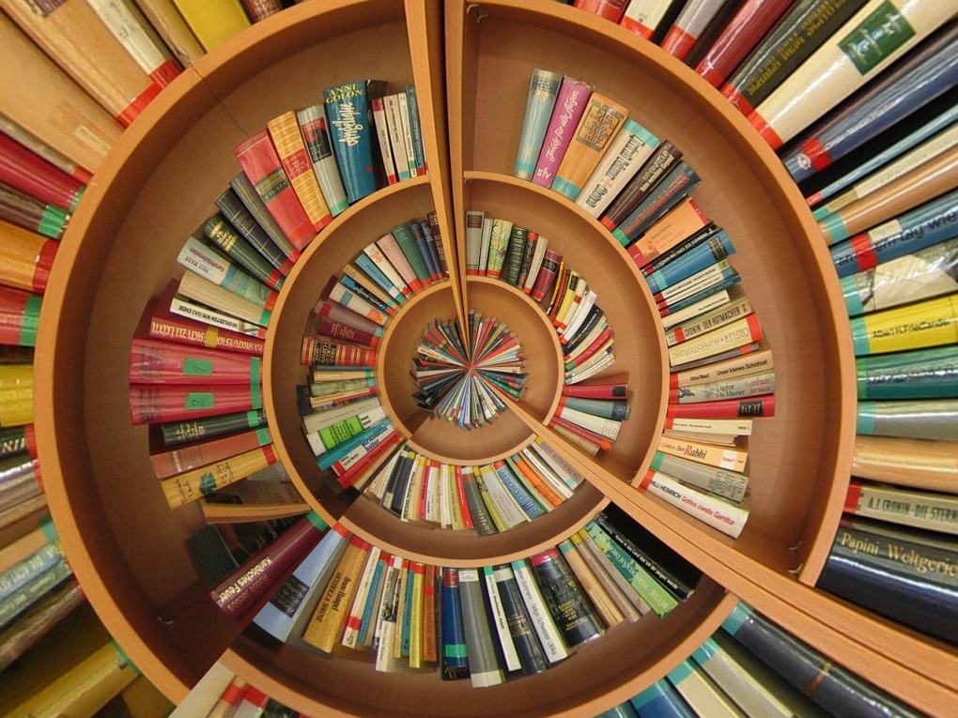
Meta description: Writer’s block—that place where you’ve got a blank page in front of you and a blank mind to match. What are you to do? Pick up a book and read.
We all hit that dreaded wall at one point or another. That place where you’ve got a blank page in front of you and a blank mind to match. Writer’s block—a state of being that is feared by many. You try to push forward, but everything you put on the page feels wrong. That’s not the right word. This part sounds so cliché. That sentence is boring. Delete. What are you to do?
Stop writing. Put down your pen or pencil, close the notebook or laptop, and shut down the computer. Find a book instead. Take that book to a nice little corner, park, or café—whatever suits you—and read! Most famous authors have been well known readers, and many find inspiration in the things they have read. J.K. Rowling, for example, read many strange tales as a child. She especially loved a story call Manxmouse by Paul Gallico about a creature with a mouse's body, rabbit's ears and monkey's paws, along with C.S. Lewis’ The Lion the Witch and the Wardrobe.
But maybe you’re more of a science fiction writer, like Ray Bradbury. His biggest influences were H.G. Wells and Jules Verne. Bradbury felt a certain writerly kinship with Verne in particular, “a writer of moral fables, an instructor in the humanities. He believes the human being is in a strange situation in a very strange world, and he believes that we can triumph by behaving morally."
Not a Harry Potter or sci-fi fan? Ernest Hemingway found inspiration in the works of many other writers, and sources beyond that:
"Mark Twain, Flaubert, Stendhal, Bach, Turgenev, Tolstoy, Dostoyevsky, Chekhov, Andrew Marvell, John Donne, Maupassant, the good Kipling, Thoreau, Captain Marryat, Shakespeare, Mozart, Quevedo, Dante, Virgil, Tintoretto, Hieronymus Bosch, Brueghel, Patinir, Goya, Giotto, Cézanne, Van Gogh, Gauguin, San Juan de la Cruz, Góngora—it would take a day to remember everyone. Then it would sound as though I were claiming an erudition I did not possess instead of trying to remember all the people who have been an influence on my life and work.”
Hemingway even included painters and musicians as his sources of inspiration. It all depends on you. Sometimes looking at a work of art can move a person—spark the creative side of the brain to life. They say a picture is worth a thousand words after all. A painting could be that and more if it speaks to you and your style of writing.
Then, there is music. Sometimes listening to lyrics can be just as effective as reading literature. Or perhaps it is not the words, but the melodies that enrapture your attention. Maybe a certain rhythm matches the kind of rhythm you hope to achieve in your writing. Inspiration is out there!
As for myself, I lean towards two very different kinds of writing—nature writing and historical fiction. For the nature writing side of things I go outside, I travel, and I write in the moment. It’s important to be there to notice things, everything around me, to recreate that moment in the pages of my journal. It is a more non-fiction sensory kind of writing, and so sometimes just meditating in the outdoors is inspiration enough. As to the historical fiction, I have been especially inspired by the Outlander series by Diana Gabaldon, as well as anything having to do with ancient Rome. Steven Saylor was another author I read growing up, who wrote a murder mystery series in an ancient Roman setting, and I have more recently been drawn to the I Claudius series by Robert Graves.
What you write depends on what you read—and vice versa. The two often go hand and hand. When you find yourself with writer’s block, don’t force it. Step away from the world you are trying to create and hop into someone else’s for a while.
Sources:
http://www.huffingtonpost.com/2013/07/03/author-writing-influences_n_3540905.html

