The Book You Carry
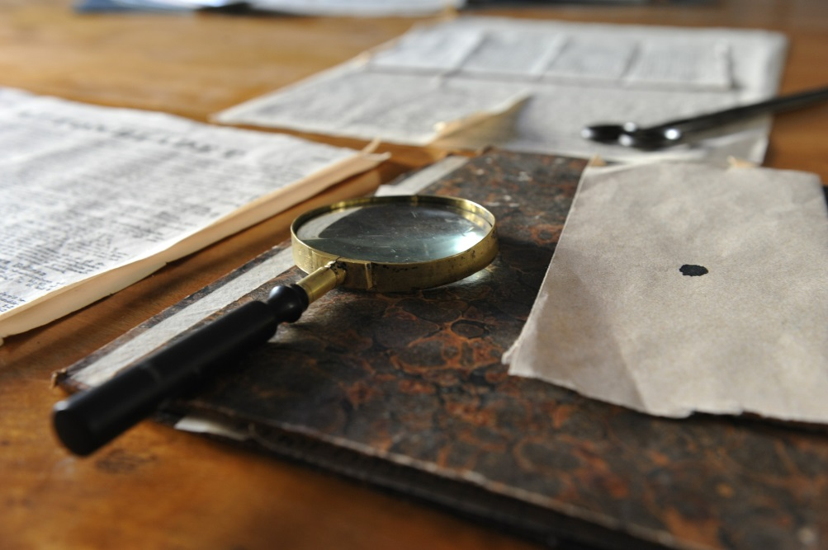
Metadescription: Many of us have a childhood book that has stuck with us our entire lives. What is the book that you carry?

“Cautiously Nancy crawled out onto the jutting rock and took a packet of matches from her pocket. She struck one, shielding it from the wind, and held it to the kindling.
As the smoke arose, a gruff voice behind her suddenly barked, “Put out that fire!”
―Carolyn Keene, The Secret of Shadow Ranch
All my life, mysteries have intrigued me to no end. Growing up, I learned to read on the Nancy Drew Mystery Stories by Carolyn Keene, and when Her Interactive released the Nancy Drew PC games, I was hooked. Where the mystery was once limited to the words on the page and my imagination, I could now jump into Nancy’s shoes and solve the puzzles, piece together clues, and reveal the answers to the final mystery. I could snoop through the crime scene of an old vandalized library, drive Nancy’s little blue roadster, and uncover secret passageways in dozens of old mansions. Long lost treasures and ancient dwellings were no match for a keen sleuth like Nancy Drew, and through her eyes I could uncover it all.
The adventures that had once enthralled me in the pages of a book now had me drawn to another world created by Her Interactive. But beyond the thrill of hopping into these virtual mysteries, I realize now how much they taught me. From deciphering Morse code by a lighthouse off the coast of Washington to learning the history of Marie Antoinette in a centuries-old French castle, these games fervently worked my brain and fed me interesting tidbits on all different realms of history. Though they have changed over the years, I still follow up on every game released, and have a revived passion for collecting the original books as well.
I still love mysteries, and find my hunger for them seeping into my reality. I came to find that ancient histories are a mystery in themselves, and so when it was time to pick a course of study in college, Classics became a big part of that endeavor. More recently, I found myself on an archaeological dig in Greece, piecing together clues from the past like the savvy sleuth herself. It was a thrill to uncover in the dirt something that might not have been touched for centuries.
Nancy Drew was the mystery of my childhood, but it seems that the mystery she instilled is still with me. I’ve found mysteries in my own ways and though I haven’t dabbled too much with writing mysteries, they do make their way into my stories on occasion. It makes me wonder how often children’s books have such an impact on a person. Do Goosebumps readers find themselves drawn to the horror genre as they grow older? How about the Magic Treehouse series? Do children who read these books grow into adventurous adults, always seeking some fantastical journey? And then you have the kids who can’t get enough of books like Captain Underpants. Do they grow into adults as eccentric as the pages of their favorite childhood choosing?
For me, and I imagine many others, there has been at least one book that is the most memorable—the one from my childhood that gave me my first thrills in life, the one that influenced my liking to many real adventures, and the one that still drives my penchant for a good mystery. For me, that book is Nancy Drew. What is the book that you carry?
Sources:
http://www.series-books.com/nancydrew/nancydrew.html
http://www.herinteractive.com/

