Keep Writing and Snack On
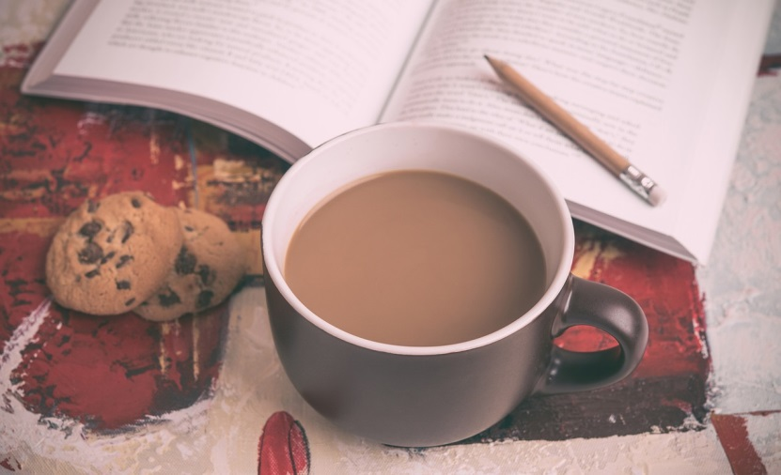
Meta description: What do you snack on when you sit down to read or write? Check out what these famous writers chose to munch on….
As I sit down to write, I am already thinking about what kind of snack I will delve into as my reward. Will it be pretzels and M&Ms? Mint chocolate chip ice cream? Or maybe a plate of salted corn chips with pineapple salsa? We all have little tricks to keep us going as we work. Sometimes it’s a reward system, and other times we snack as we go. Snacking while writing is common amongst writers. Many famous authors have had their go-to nibbles and recipes to keep the creative juices flowing.
Agatha Christie, for example, was partial towards cream, so much so that she would keep a mug of it by her typewriter to sip from while she wrote. Her favored cup had ‘Don’t be greedy’ written on the side of it, but that didn’t stop her consumption. In Devon County, where she grew up, it was traditional to have scones with clotted cream, but Christie would ditch the scones and eat the cream by the spoonful.
Jean-Paul Sartre was another writer who had a penchant for the snack. His particular craving was the nut-and-honey-based confection, halva. When he was drafted into the army during World War II, he would request books and halva. He would panic if it did not arrive immediately. “I got your books but no halva. Is there another package?” he wrote to his partner Simone De Beauvoir. When it did arrive, he would snack away with no time to waste.
Sylvia Plath was one who loved cooking nearly as much as she loved writing. When she moved to England from the United States, she asked her mother to send her The Joy of Cooking, which she read as avidly as any novel. Baking became her specialty—lemon-pudding cake, apple cake, devil’s food cake, banana cake, and the more unusual tomato-soup cake became some of her favorites.
The list of authors and their preferred snacks goes on—H.P. Lovecraft would eat spaghetti every night and a doughnut and cheese every morning; Daniel Handler (Lemony Snicket) prefers raw carrots and drinks water while writing; Jack Kerouac would indulge in apple pie (like his character, Sal, in On the Road); Walt Whitman enjoyed coffee cake; and Stephen King takes a fork to cheesecake before sitting down to write.
Your own chosen snack might not be as rich as pure cream or as bizarre as tomato-soup cake, but it is interesting to know what each writer deems his or her favorite. If you are looking for something a little healthier to maximize your productivity, there are some flavorsome options out there. Try a green fruit smoothie, veggies and hummus, apples and cheese, nuts, or air-popped popcorn. Another tasty concoction is a writer’s homemade trail mix of almonds, cashews, dried cranberries, sunflower seeds, and some dark chocolate chips to satisfy that sweet tooth.
For more satisfying brain foods check out this nifty page (http://authorunlimited.com/brain-food-for-writers/ ). However, if you prefer the more indulging treats, and something like Butterfinger Cookie Dough Cheesecake Bars tickle your fancy, you may want to check out Huffington Post’s selection of the 50 best dessert recipes of all time (http://www.huffingtonpost.com/2013/09/19/best-desserts-recipe_n_3948897.html ). Being of the Sylvia Plath baking tendency myself, I am off to bookmark a few of these recipes for later indulgence. There’s nothing like the smell of sweets in the oven to start off the fall season and get through some long days of writing.
Sources:
http://authorunlimited.com/brain-food-for-writers/
http://www.omgfacts.com/health/17215/These-Iconic-Authors-Ate-These-Snacks-While-They-Wrote-ab964-6
http://www.thedailybeast.com/articles/2012/10/12/menu-for-a-moveable-feast-10-famous-authors-and-their-favorite-foods-recipes.html
http://betterwritinghabits.com/9-energizing-snacks-that-will-keep-you-writing/
http://www.huffingtonpost.com/2013/09/19/best-desserts-recipe_n_3948897.html

