Is the Pen Mightier than the Computer?
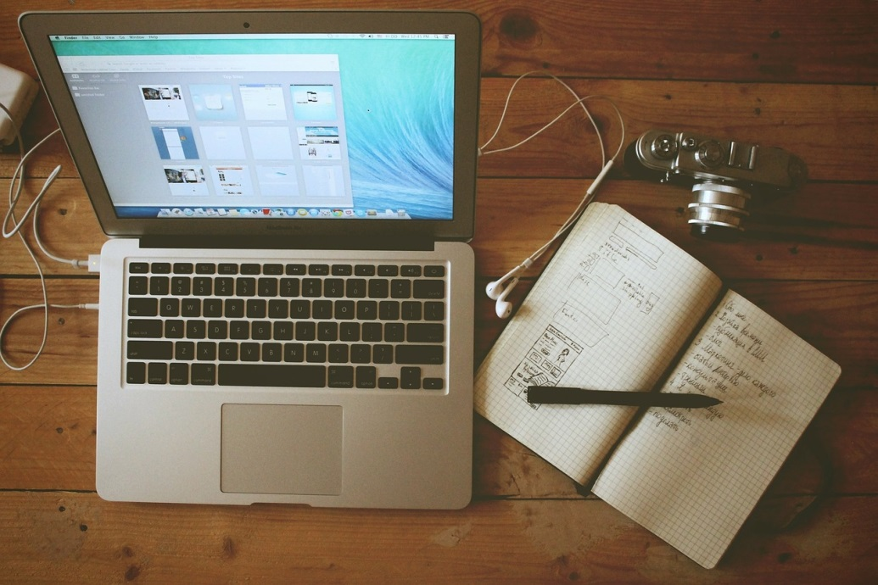

They say the hardest part of writing is beginning. Perhaps the trial runs deeper. When you go to sit down and write, what lies in front of you? Pen and paper? Pencil and notebook? Laptop or tablet? Typewriter? These are your tools—your ways of wielding the words that will bring your story to life. How do you know which is right for you?
I have broken the methods down into three simpler categories: the scribbled, the handwritten, and the typed. Writers have been found to dabble in all three categories and there are advantages and downfalls to each. Let’s break them down.
The scribbled is a method for those who work best with pencil and paper. John Steinbeck was one such scribbler—drawn to the pencil, starting each writing session with twenty-four pencils at the ready. It is said that he favored the Blackwing pencil and used three hundred pencils to write East of Eden. Though that may seem like a lot, on average one tree can make about 170,000 pencils!
Another known scribbler was Henry David Thoreau. Born to a pencil maker, perhaps his preference was predestined. As a young man, he worked in the family factory, even inventing the early American pencil by binding the soft graphite with clay for strength. Needless to say, Thoreau’s notebook was always accompanied by a pencil.
Then there is the handwritten: the means of writing with pen. In my research it seems to be the method of choice for many famous writers—Neil Gaiman, Stephen King, J.K. Rowling, and Jane Austen were just a few on this list. Gaiman had much to say on the topic in an interview with BBC:
"It started in 1994 when I wrote the novel Stardust—in my head I wanted it to be written in the same way as it would have been in the 1920s, so I bought a big notepad and Waterman pen.
It was the first time I'd used a fountain pen since I was about 13. I found myself enjoying writing more slowly and liked the way I had to think through sentences differently. I discovered I loved the fact that handwriting forces you to do a second draft, rather than just tidying up and deleting bits on a computer. I also discovered I enjoy the tactile buzz of the ritual involved in filling the pens with ink.”
Stephen King also writes in his preferred Waterman fountain pen for many of the same reasons, forcing him to slow down and think about what he is writing. Jane Austen’s method was slightly different from modern pen-users, but handwritten nonetheless—a quill pen and iron gall ink. She even brewed her own recipe for the ink, which you can find here: http://www.fountainpennetwork.com/forum/topic/93473-jane-austens-ink-recipe/
Finally, we have the typed—typewriter or computer—anything that does not require pen or pencil. Interestingly enough, I found it difficult to uncover any writers today who take advantage of the advanced technology we have. Cormac McCarthy and Agatha Christie are two typists who preferred typewriters. With over a dozen works typed on it, McCarthy’s typewriter was recently sold at an auction for $254,500. His replacement—another typewriter for $11.
Each writer has his or her own methods, and each method has its pros and cons. Using the pencil is a tactile process—you feel what you are writing and can, if you prefer, measure your progress by how many pencils you use; yet, there is always the dreaded writer’s cramp. The process of the handwritten pen forces one to slow down and think about each word, making for thorough work; yet, it is long and laborious and takes some time. The computer also has its advantages. It is quicker and easier to share, and has access to online dictionaries, spell check, and synonyms if you’re looking for just the right word; yet again, there are drawbacks. The freedom of typing can lead to many mistakes and the physical presence of the writing is less personal, not to mention straining on the eyes.
The methods of writing are of endless variance. With so many tools, it is not always easy to pick just one. Each has its drawbacks and each has its benefits. Are you a scribbler or a hand-writer? A typist? Or perhaps a combination of the three? Maybe you are an Ernest Hemingway! This famous writer mixed up the processes with both pencil and typewriter. The only way to find out what works best is to try them yourself. So get writing! Wield your words, and choose your weapon carefully.
Sources:
http://flavorwire.com/410384/the-writing-tools-of-20-famous-authors/
http://www.bbc.com/news/magazine-18071830
http://www.writerstreasure.com/pen-and-paper-vs-computer/

